KAMALESH T

Best Enlist

Automatic certificate – generator

In this project I used pandas and pillow module.pillow for viewing

certificate template and drawing names and details on them by using

default keys in pillow such as image,imagefont,imagedraw .i created a

excel file as csv which contains participants list and their details and i

imported the excel file in program using pandas module .i used to dict

key for using excel as dict if we used name in excel which has all the

names like that for all .I used imagedraw in pillow module for writing

names and details in certificate and I created a separate folder named

certificates for storing the certificates I created.hereby I submitted the

screen shots of certificate folder and sample certificate

Program:

import pandas as pd  
from PIL import Image,ImageDraw,ImageFont  
f=pd.read_csv("participants1.csv")  
f  
records = f.to_dict(orient='record')  
font = ImageFont.truetype("OpenSans-Semibold.ttf",size=25)  
def generate_cert(data):  
    template = Image.open("template1.jpg")  
    draw = ImageDraw.Draw(template)  
    draw.text((140, 145), str(data['Name']), font=font, fill='black')  
    draw.text((140, 170), data['Gender'], font=font, fill='black')  
    draw.text((423, 145), data['Project manager'], font=font, fill='black')  
    draw.text((423, 170), data['mentor'], font=font, fill='black')  
    draw.text((174,385),data['num'],font=font,fill='black')      
    return template  
for record in records:  
    certificate = generate_cert (record)  
    certificate.save(f"certificates/{record['Name']}.jpg")

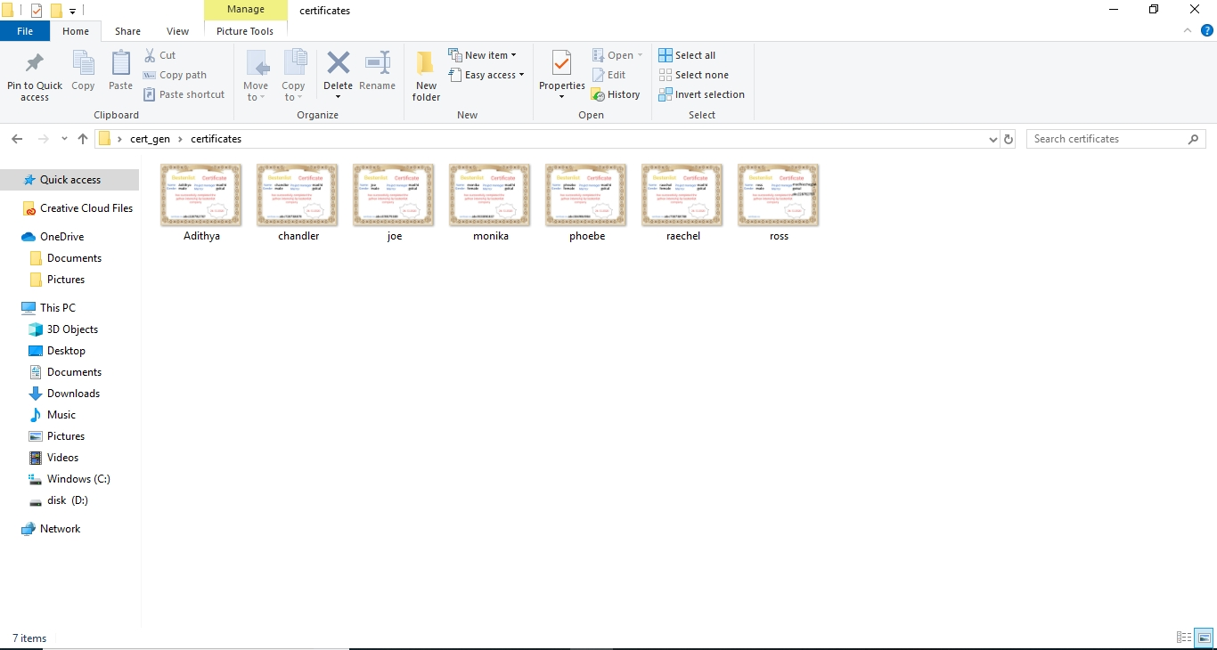Screenshot:

